BUILD TOOL: MAVEN ESSENTIALS

WHAT IS MAVEN
- maven is a automation and project management tool develop by Apache software foundation that manages the dependencies and creates the artifacts.it is based on pom (project object model)
- maven can build any number of projects into desired output such as .jar .war metadata
- It is mostly used for java-based projects
- it was initially release in 13 July 2002 & written in java
- The meaning of maven is a "accumulator of knowledge"
- maven helps in getting the right jar file for each project as these may be different of separate packages.

WORKFLOW OF MAVEN
Whenever an application is developed, we need the following components
- Database
- Programming Language
- Build Tool
- Cloud / Deployment Environment
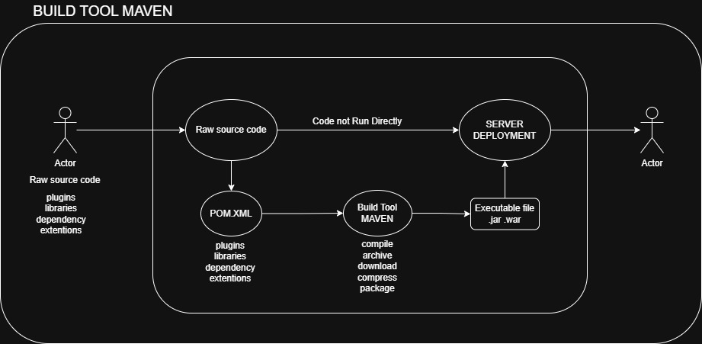
- Whenever a developer writes an application, the code is in raw source code format (.java).
- This raw source code cannot be deployed or executed directly on a server.

- To develop the project successfully, the developer requires multiple external components such as:
- Dependencies
- Libraries
- Plugins
- Extensions

- These components are available only on the developer's local machine.
- If the project is pushed to GitHub without managing these components properly, another developer or server that clones the project will not have the required dependencies, and the application will fail to build or run.

- To solve this problem, the developer creates a Maven configuration file called pom.xml.
- pom.xml is the heart of a Maven project.

- Inside the pom.xml file, the developer specifies all the required information, such as:
- Project details
- Java version
- Dependencies
- Libraries
- Plugins
- Build configuration

- When Maven is executed (for example, using mvn clean install), it reads the pom.xml file and automatically:
- Downloads all required dependencies and libraries from the Maven Central Repository.
- Compiles the source code.
- Runs tests.
- Packages the application.

- After the build process is completed, Maven generates a deployable artifact (executable file), such as:
- .jar (Java Archive)
- .war (Web Archive)

- Finally, the generated .jar or .war file is deployed to a server or cloud platform, such as:
- Tomcat
- Docker
- Kubernetes
- AWS EC2

- Once the artifact is deployed, the application starts running and becomes accessible to end users.

TERMS IN MAVEN
- Compile
conversion of alphanumerical language (code) into binary for the server
- Build
converting your raw source code into the executable file also called as deployment file/artifact/module

MAVEN BUILD LIFECYCLE
Maven Has 3 Lifecycles
- Clean
- Default (Main Build Lifecycle)
- Site
- Clean Lifecycle
- Deletes old build files
- Deletes target/ folder
- command: mvn clean
- Default Lifecycle
- validate
validate the project is correct and all necessary information is available
- compile
conversion of alphanumeric language into the binary for the server
- test
integrated testing source code
- package
take the compiled code package it into the format like .jar .war
- verify
ensures quality criteria are met
- install
packages install on local repo
- Deploy
push packages into final remote repo
Command: (mvn clean package)

Dependencies
Dependencies mean the libraries required for the project (language version)
Repositories
it’s a directory of packaged jar files.

BUILD TOOLS
- c and c++----> make file
- .net---------> .net7 / .net8 / MSBuild / dotnet cli
- java---------> Apache ant / Apache maven / Gradle
- node.js ----> npm / yarn / npx
- php ---------> php artisan

POM (Project Object Model)
- pom (project object model) refers to the XML files that have all the information regarding project and configuration details.
- main configuration file is pom.xml
- it has the description of the project details regarding the versioning and configuration management of the project
- The xml file is in the project home directory
Pom.xml File Contains
- metadata
- dependencies
- output (.jar .war)
- description21

Difference Between the Ant & Maven
ANT
- it is a tool box
- it is mainly a build tool
- it is less preferred than maven
- there is no lifecycle in ant
- ant is procedural you need to provide the info about what to do and when to do through code
MAVEN
- it’s a framework
- it is a build tool as well as project management tool
- it is more preferable
- there is lifecycle in maven
- it is declarative, everything you define in the pom.xml file

How To Read the Version
Example {20.4.5}
- 20--------> major change
- 4---------> minor change
- 5---------> add the patches (little bit changes)

Interview Questions
1.What are the key benefits of using Maven in a project?
Benefits include standardized project structures, dependency management, build automation, and simplified project configuration.

2.Describe the Maven project structure. What are the main directories and files?
Maven project structure includes directories like src, target, and files like pom.xml.

3.Explain the lifecycle phases in Maven. How are they executed?
maven lifecycle consisting multiple phases like the dependencies, compile the code, test, package, install, deploy and it is executed in sequentially

4.What are dependencies in Maven? How do you declare them in a POM file?
dependencies in nothing but the libraries required for the project which are declare in the pom file under the dependencies section

5.what is a maven repository and what are the repositories.
Maven repositories basically stores the artifacts while there are the local, remote, and central repositories.

6.How do you create a custom Maven archetype?
Custom archetypes are templates for Maven projects, created using the archetype:create goal.

7.How can you create a multi-module Maven project?
Multi-module Maven projects are created by organizing related projects into a parent-child hierarchy.

8.How does Maven handle project dependencies conflicts?
Maven resolves dependency conflicts using dependency mediation or version declarations in the POM file.

9.How can you skip certain phases of the Maven lifecycle?
Maven allows skipping phases using command line options like -DskipTests.

10.Explain the difference between Maven's clean, validate, compile, test, package, install, and deploy phases.
Maven lifecycle phases handle different stages of the build process, like compilation, testing, packaging, etc.

11.What is the purpose of Maven profiles? How do you define and activate them?
Maven profiles define configurations for different environments and are activated using profiles in the POM file or command line.

12.How do you execute a Maven build from the command line?
Maven builds are executed from the command line using the mvn command.

13.How does Maven manage project versions?
Maven manages project versions through version numbers specified in the POM file.

